Testing Code Coverage

This section will guide you to:
- Create and commit a Jenkinsfile which uses JaCoCo
- Configure a pipeline to run from a Jenkinsfile and publish coverage results
Please Note: This demo is incremental, you should have completed the previous demos in order to proceed with this demo.

Step 1: Creating a Git repository for the Review Analyzer program
- Login to your Github account.
- Click on the plus icon next to the profile picture and select New repository from the drop-down menu.
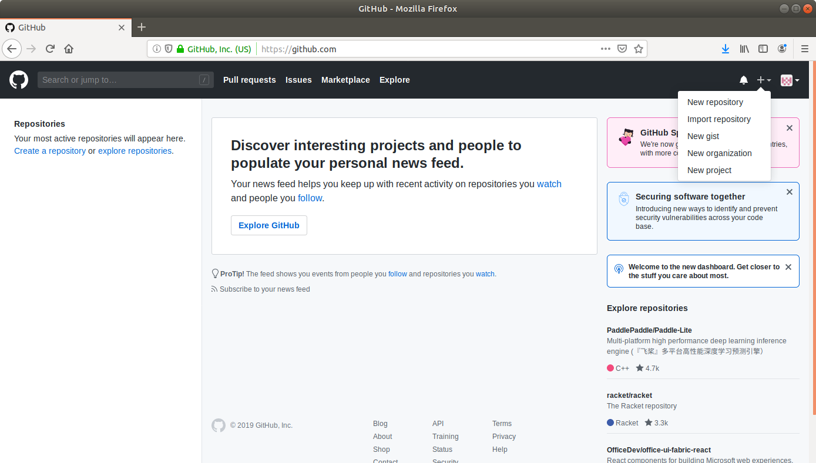

- Fill the required fields in the Create Repository form.
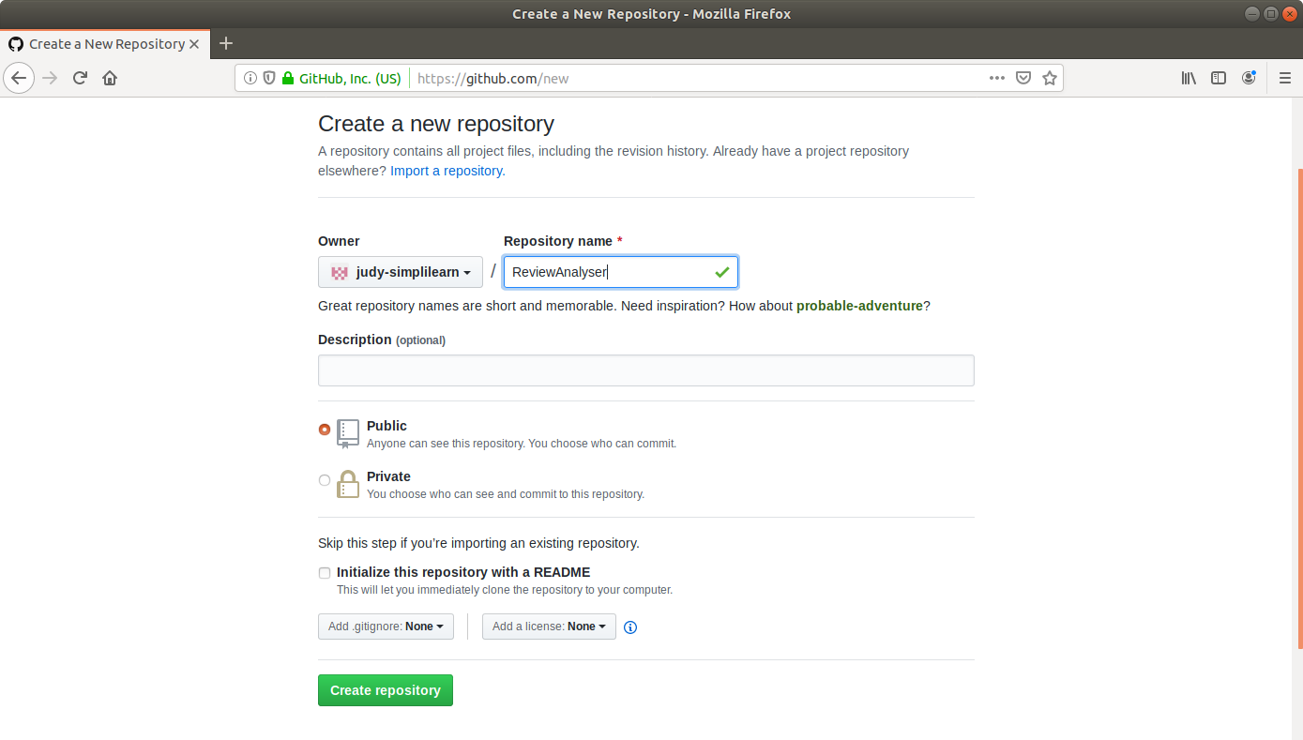
- Click on the Create Repository button.
- Click on the Clone or download button and copy the URL.
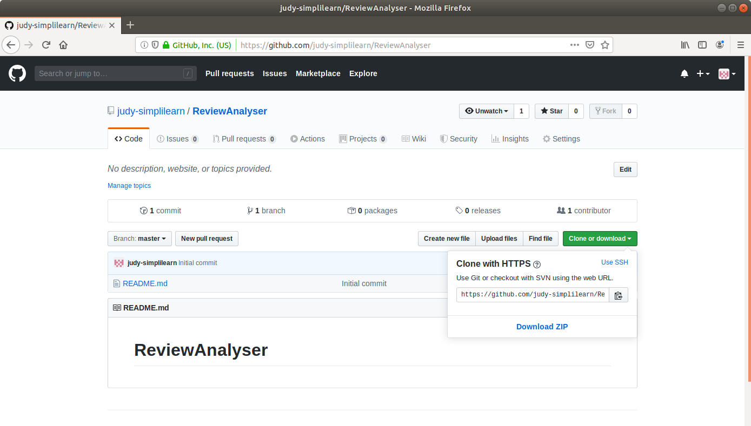
Step 2: Generating a spring boot project
- Go to ​start.​spring.​io/​
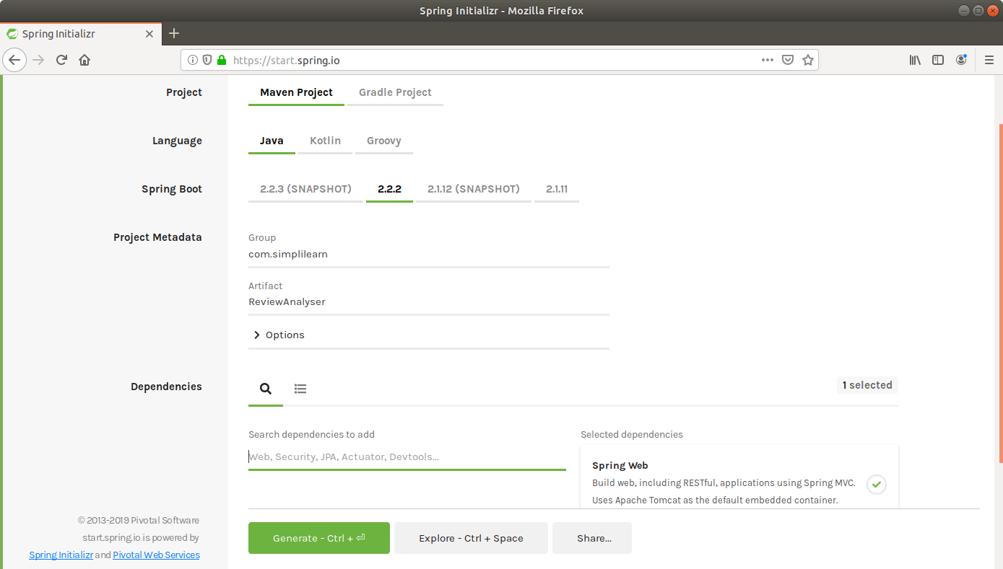
- Select Maven as the project type.
- Fill Group and Artifact with appropriate values. For example, com.simplilearn and ReviewAnalyser.
- Add Web to Dependencies.
- Select Packaging: Jar
- Select Java: 8
- Click on Generate Project.
- The generated skeleton project should be downloaded as a zip file.

Step 3: Adding the code for word count to the repository
- Open the terminal and navigate to an appropriate location.
- Run git clone [URL] to clone the repository.
- Unzip the downloaded spring boot project to the cloned repository.
(cd Downloads
unzip Review-Analyser.zip)
Copy the contents of Review-Analyser folder present in dowsnloads and paste it into your repository folder)
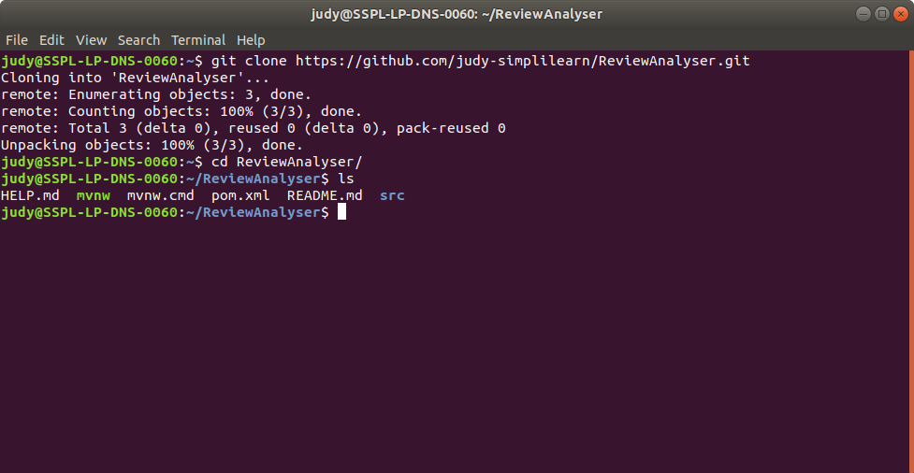

- Navigate to the ReviewAnalyser folder within the src folder.
- Open the ReviewAnalyserApplication.java in a text editor.
- Add the following method to the file and save it.
package com.simplilearn.ReviewAnalyser;

import org.springframework.boot.SpringApplication;
import org.springframework.boot.autoconfigure.SpringBootApplication;

@SpringBootApplication
public class ReviewAnalyserApplication {
public static double getWordCount(String review){
int count = 0;

String string[] = review.toLowerCase().split("([,.\\s]+)");
for(String s : string){
count++;
}
return count;
}
public static void main(String[] args) {
SpringApplication.run(ReviewAnalyserApplication.class, args);
}

}

- Navigate to the ReviewAnalyser folder within the test folder.
- Open the ReviewAnalyserApplicationTests.java in a text editor.
- Add the following test method to the file and save it.
package com.simplilearn.ReviewAnalyser;

import org.junit.Test;
import static org.junit.Assert.*;
import org.springframework.boot.test.context.SpringBootTest;

@SpringBootTest
class ReviewAnalyserApplicationTests {

private ReviewAnalyserApplication analyser = new ReviewAnalyserApplication();
@Test
public void testWordCount() {
assertEquals(7,analyser.getWordCount("Train to win in the digital economy"));
}
}
- Save the file and exit the text editor.
- Open the pom.xml and add the following dependency.
<dependency>
<groupId>junit</groupId>
<artifactId>junit-dep</artifactId>
<version>4.8.2</version>
<scope>test</scope>
</dependency>
- Add the jacoco plugin to pom.xml with the following xml code:
<plugin>
<groupId>org.jacoco</groupId>
<artifactId>jacoco-maven-plugin</artifactId>
<version>0.8.3</version>
<executions>
<execution>
<id>default-prepare-agent</id>
<goals>
<goal>prepare-agent</goal>
</goals>
</execution>
<execution>
<id>default-report</id>
<phase>prepare-package</phase>
<goals>
<goal>report</goal>
</goals>
</execution>
</executions>
</plugin>
- Save the file and exit the text editor.

Step 4: Creating and committing a Jenkinsfile
- Navigate to the ReviewAnalyser root directory where the pom.xml is.
- Open a new text file vi Jenkinsfile and add the following script to it.
pipeline {
agent any
stages {
stage("Compile") {
steps {
sh "mvn compile"
}
}
stage("Unit test") {
steps {
sh "mvn test"
}
}
}

post {
always {
step([$class: 'JacocoPublisher',
execPattern: 'target/*.exec',
classPattern: 'target/classes',
sourcePattern: 'src/main/java',
exclusionPattern: 'src/test*'
])
}
}
}

- Save the file as Jenkinsfile with no extension.
- Commit the changes to the remote SCM.
- Run git add .
- Run git commit -m “Add logic and test”
- Run git push -u origin master
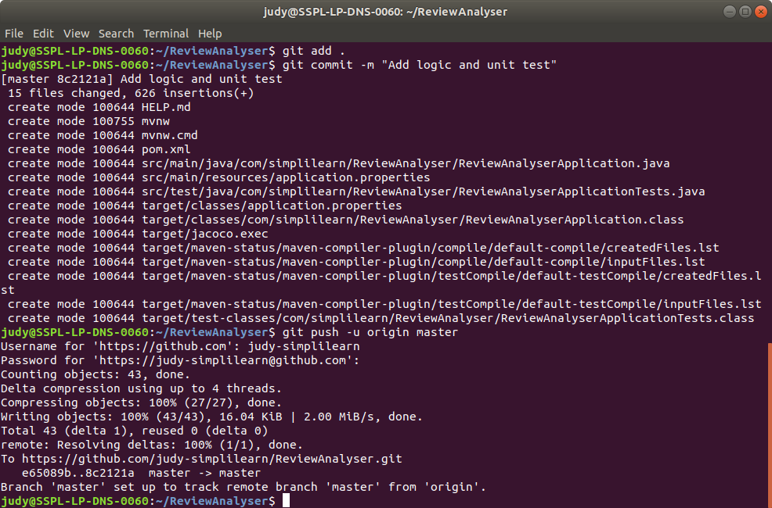
Please Note: In case you get an error while executing git push -u origin master, as shown in the screenshot below, execute git push -u origin main
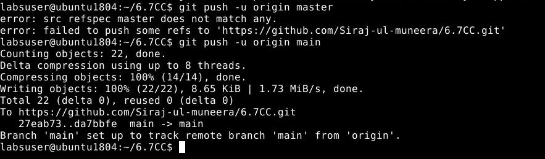
Step 5: Creating a multistage pipeline in Jenkins
- Go to Jenkins dashboard.
- Click on New Item.
- Enter a name for your build job.
- Select Pipeline as the build job type.
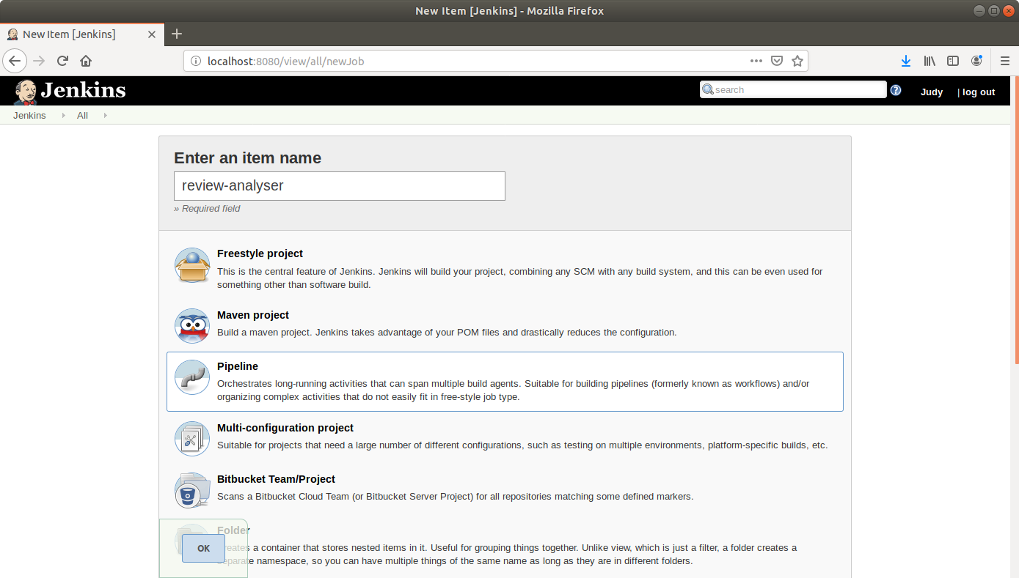

- Click OK.
- On the configuration page, scroll down to the Pipeline section.
- Change Definition from Pipeline script to Pipeline script from SCM.
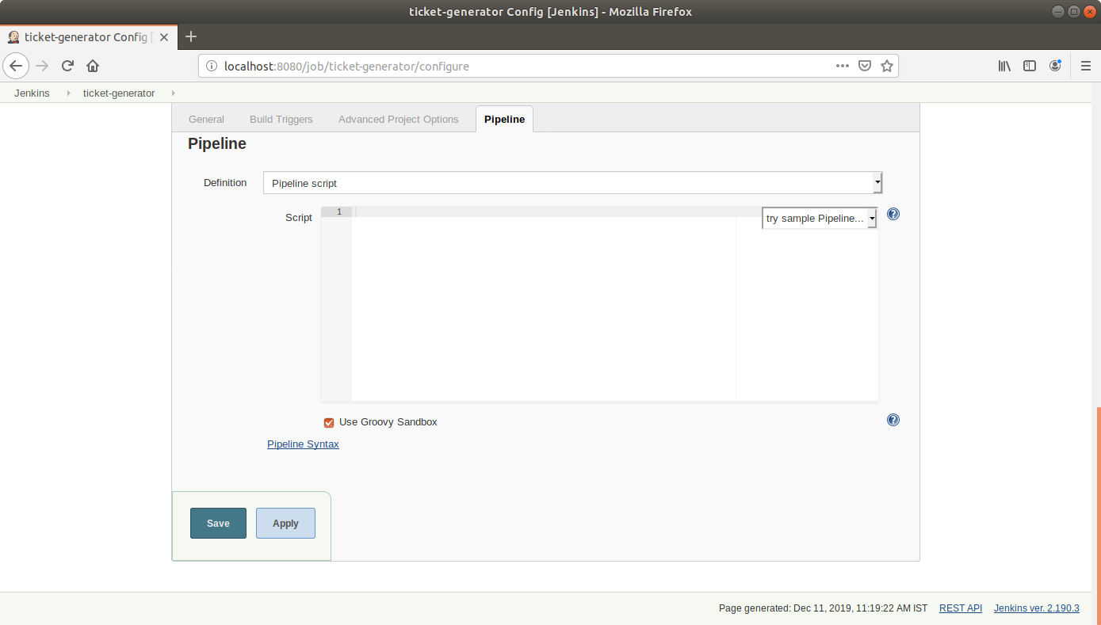
- Select Git in SCM.
- Add the repository URL and the branch to build (master or main).
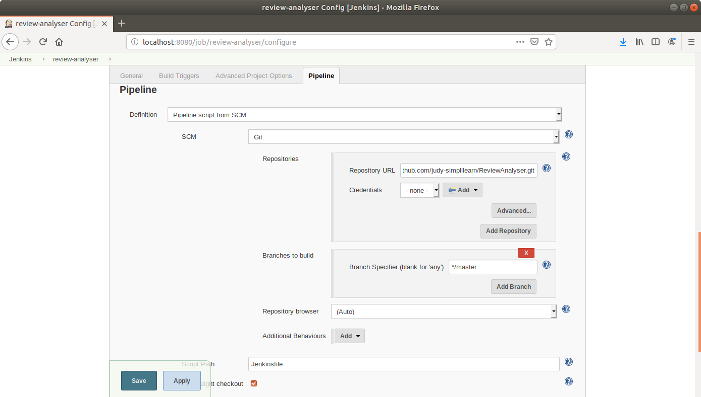

- Click Save.

Step 6: Running a multistage pipeline in Jenkins
- Click on Build Now in the project window.
- Jenkins will now build your pipeline and output the logs.
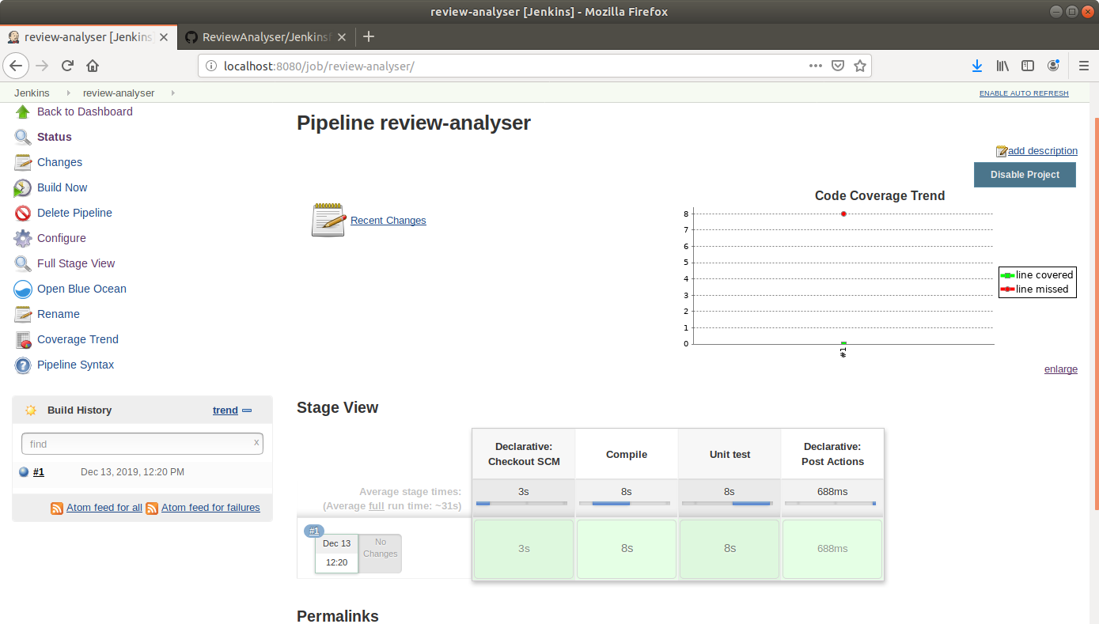

- Click on Coverage Trend to view the coverage trend.


